 | Mound Valley  News and Notes | Nov. 2021
_______________________________________________________________
Important Dates:
3 Picture Retakes and Group pictures
4 4:30 JrHigh Wrestling Intra-squad scrimmage
8 4:30 JrHigh Wrestling @ Columbus
11 4:30 JrHigh Wrestling @ Cherryvale
12 Prek Child Find
13 9:00am JrHigh Wrestling @ Columbus
15 5:30 District Site Council meeting, JrHigh BB practice begins
16 4:30 JrHigh Wrestling @ Frontenac
17 8th grade to LCC
19 Popcorn Friday, 8th grade Orientation at the High School
22 3:30 JrHigh Wrestling @ Chanute
23 3:30 JrHigh Wrestling @ Parsons
24-26 No School-Thanksgiving Break
(This calendar is subject to change. Please check the Mound Valley calendar on the district website for changes and updates at usd506.org Click on the Calendar button, then choose the Mound Valley calendar. You may have to choose the current month to update the calendar.)
- Athletics
Congratulations to our Volleyball and Football coaches and players for a great year! Way to make Mound Valley proud.

- PTO Information
What a GREAT night in the Valley for our students, families, community, and staff! Our annual Chili Supper looked a little different this year as we held the event outside in front of the school. We had games for students to play, a cornhole tournament, live and silent actions, classroom project raffles, 50/50 pots, and yummy food to eat! Families brought their lawn chairs and visited as they watched a fun evening of events. The PTO funds help support learning and school activities such as skating in P.E, book fair, educational resources, and field trips. Thank you to Kristen Hennon, PTO President, and all who helped make this a successful event. The following is a list of a some of our donatators:
Bartlett Co-op Association, Coffeyville Walmart
Bleacher Gear, Tulsa Oilers, Buck Brush Adventures, LLC , Dee Jones
Parsons Ace Hardware , Mary’s Kids Daycare
Butterfly Funhouse Childcare
Chris Gillman Dozer , Commercial Insurance Agency , PEC, Cosmosphere, Hutchinson
K-State, Emporia State University
City of Mound Valley, Exploration Place, Wichita
Labette Bank, Eye Care Associates of Parsons
Show Me Kansas Farms, Hockett’s Auto and Diesel
Tulsa Zoo, Kansas City Zoo , Wonderscope, KC
Keltz Construction , Coffeyville Feed, Kesler Photography, David Winters , Magnolia
Bethany McCarty/31 bag , Muller Construction
Labette Insurance , Gia Rose, Meredian Analytical
Parsons Fine Jewelry, Mound Valley Fire Dept
Rick’s Ribs, Bartlett Co-op of MV , Rural Route II
Whitaker’s Mowing Service , Parsons Glass
Rebecca Dobbins, O.D., P.A. , Diana Vernon
Mike and Casey Cramer, Rolling Hills Zoo
Scooters, Sporting Life Taxidermy
Jody Burzinski/LCC, The Magic House, St. Louis
Pete’s of Erie
The National WW1 Museum and Memorial
Magman’s Corner/The Gym
Richard & David Byrd, Darrell Riley
Twin Valley Electric , Parsons Walmart
Mound Valley Public Library , Independence Walmart, Bowen Pharmacy
- Red Ribbon Week Celebration
We kicked off Red Ribbon Week! This year's theme was "Drug Free Looks Like Me". Students were encouraged to participate each day of the week to help remind us to "Say No to Drugs" and live a drug free life.
Oct. 26th Tuesday - “Say NO TO DRUGS”: Wear RED to school! Red reminds us to stay Drug Free!
Oct. 27 Wednesday - “No Prob-llama: I’m Drug Free”: Wear some cool shades and/ or your coolest hairdo. Play it cool and always so no to drugs!
Oct. 28 Thursday -”Stomp Out Drugs”: Wear some mismatched shoes or boots today and be reminded to stomp out drugs and other addictive substances.
Oct. 29 Friday My Dream, My Future, My Choice” Come dressed as your future profession. The best lived life and career is drug free.
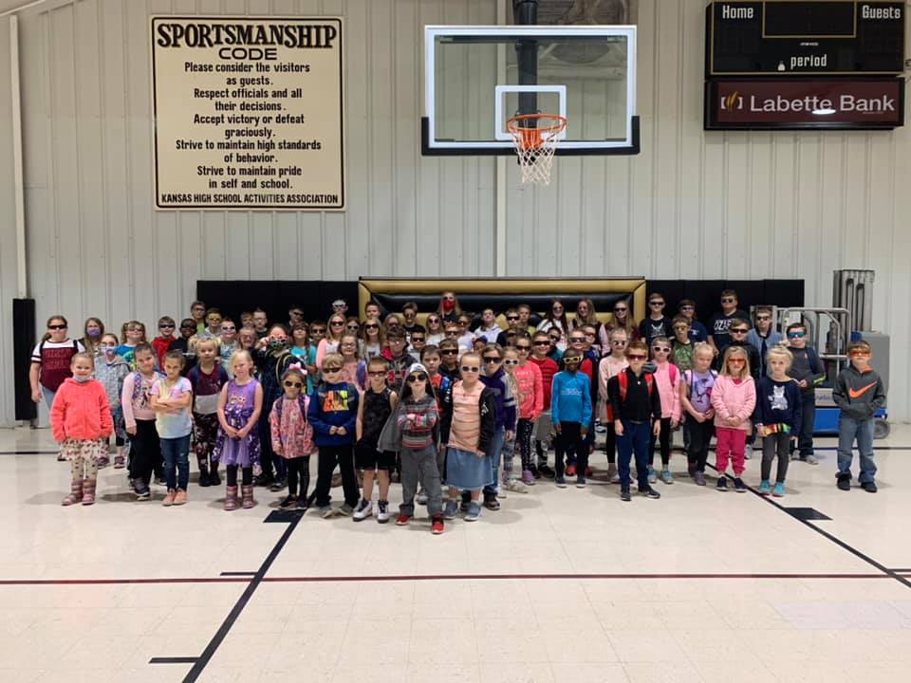

Transportation Corner/News
National School Bus Safety Week takes place the third full week of October each year. It is designed to promote school bus safety. National School Bus Safety Week is the perfect time to talk to your child about school bus safety. Tell your child that when getting on and off the bus to always watch for oncoming traffic. While at the bus stop, they should stand at least three giant steps away from the approaching bus. The observance is also a time for motorists to learn and adhere to all the bus stopping laws.
We are thankful for our bus drivers! Thank you to Brenda Gelwick, Steve Black, Dena Daniels, and Lisa Vanderhofe.

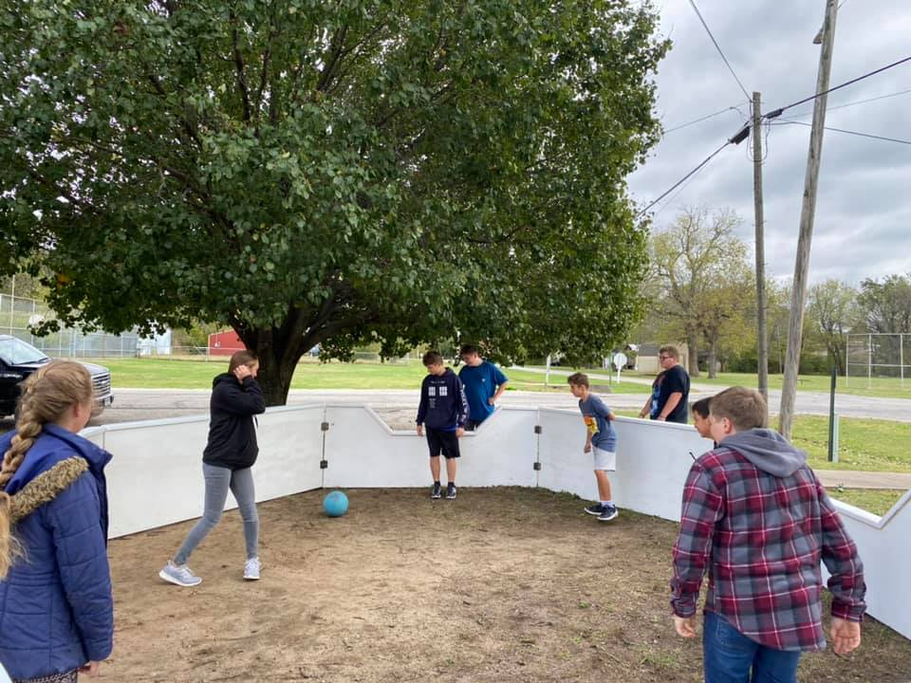

Check out our new playground equipment! Mound Valley Grade School Student Council members helped install a Gaga Pit on our playground. This project started with last year’s student council as a suggestion and has been fully implemented by this year’s council members. We are extremely proud of our student council from last year and this year. Funds for our pit came from a surplus of previous years of 8th grade Blue and Gold Fundraising, which will begin again very soon.
Gaga ball is a game that many students can play at one time and is for kids and adults of all ages. Mrs. Jessica Heit is the 8th grade teacher and Student Council Leader. What a wonderful way to give back to our school and community.

- Pre-School Screenings
If you know of a child who is three or four years of age please inform them of our Pre-School screenings. Please call the office to arrange for a screening time.
- Health
Cold and Flu season is just warming up, so remember this time of year the added importance of good hand washing. Please encourage your child to use warm water with soap and scrub for as long as it takes for them to sing “Happy Birthday” twice, making sure they get between fingers, wrists, and backs of hands too. While hand sanitizer, vitamins, and flu shots are great, hand washing is the single best way to prevent the spread of germs.
- Why School Breakfast?
Breakfast really is the most important meal of the day for kids, as it provides the necessary energy to get set for a day of learning and achievement. Some of the benefits of eating school breakfast include:
Higher Academic Scores- Studies have shown eating breakfast at school results in higher test scores.
Convenience & Value for Parents- School breakfast is ideal for busy families trying to get out the door quickly in the mornings. And at an average price of less than $2 per meal, it's a great value too!
- Title 1 information-
As a school-wide Title I program we are required, at the beginning of every school year, to tell parents they have a right to request the following information about the professional qualifications of their children’s teachers.
In addition, USD 506 must notify parents if their child has been assigned, or has been taught for four or more consecutive weeks— by a teacher who is not highly qualified.
It is not the intent of USD 506 to use teacher data as a means of drawing attention to teachers or create questions as to the competency of a school’s teaching staff. Rather, it is our intent to provide this data as a means of working together in upgrading teaching skills and improving instruction. Parents may request access to their student’s state assessment scores.

